**Shashwat Tripathi D20A 64**

**Blockchain EXP 10**

**Aim :** Demonstrate Hyperledger Fabric Demonstration

**Theory:**

Hyperledger Fabric is a permissioned blockchain framework developed as part of the Hyperledger project, under the Linux Foundation. It is specifically designed for enterprise applications where organizations need a secure and efficient system for conducting transactions and sharing data. Here are the key features and concepts of Hyperledger Fabric:

**Key Features**

**Modular Architecture:** Hyperledger Fabric offers a highly modular architecture, enabling developers to customize various components such as consensus mechanisms and membership services to fit specific use cases.

**Permissioned Network:** Unlike public blockchains, Hyperledger Fabric operates on a private or permissioned network, where all participants are authenticated and known to one another.

**Chaincode:** Smart contracts in Hyperledger Fabric are known as "chaincode." These can be written in Go, Java, or JavaScript and serve to implement business logic on the network.

**Channels:** Fabric supports the creation of channels, which function as private sub-networks that allow specific participants to transact confidentially within the broader network.

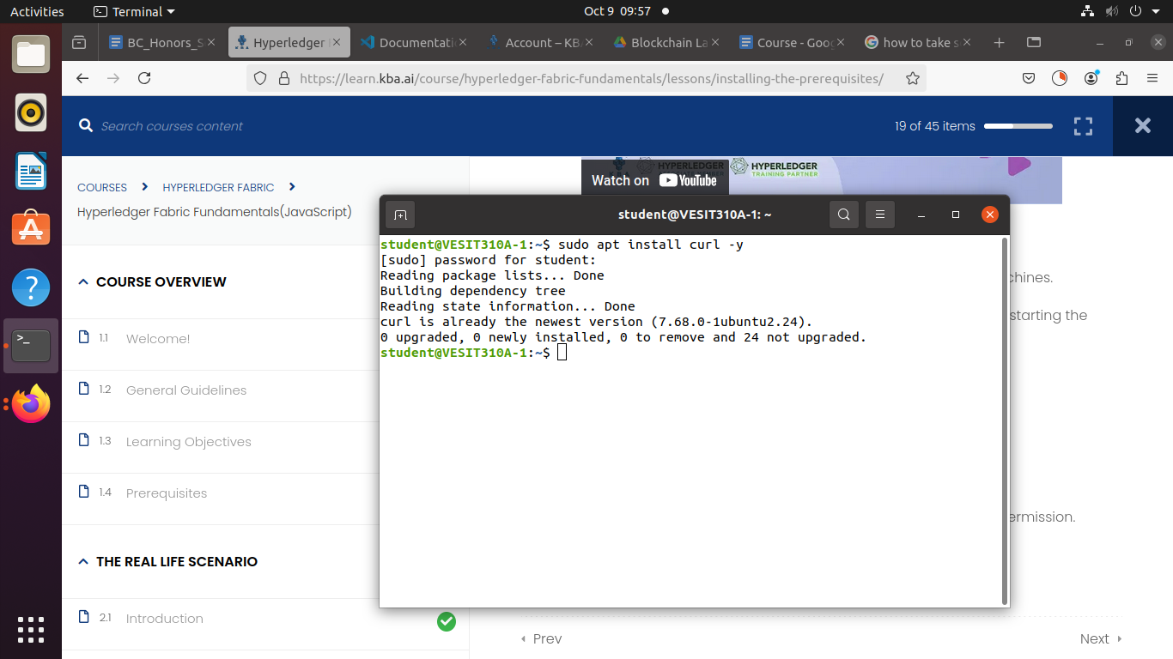

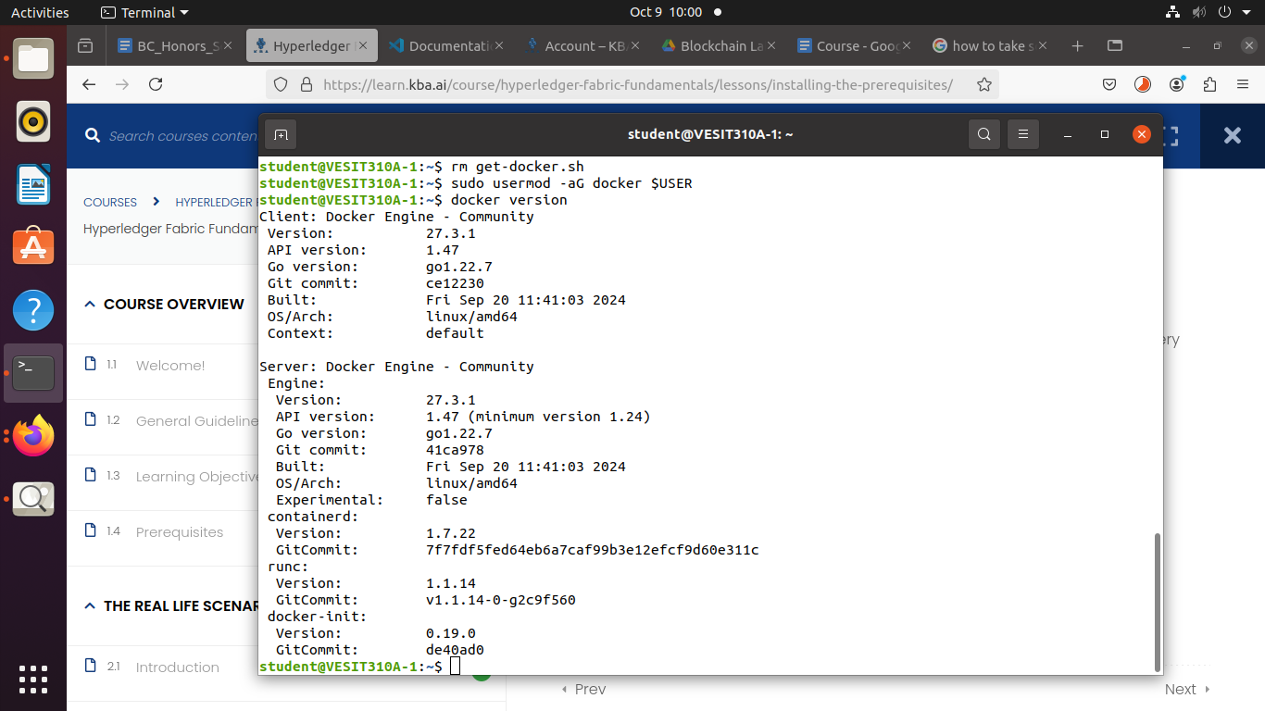

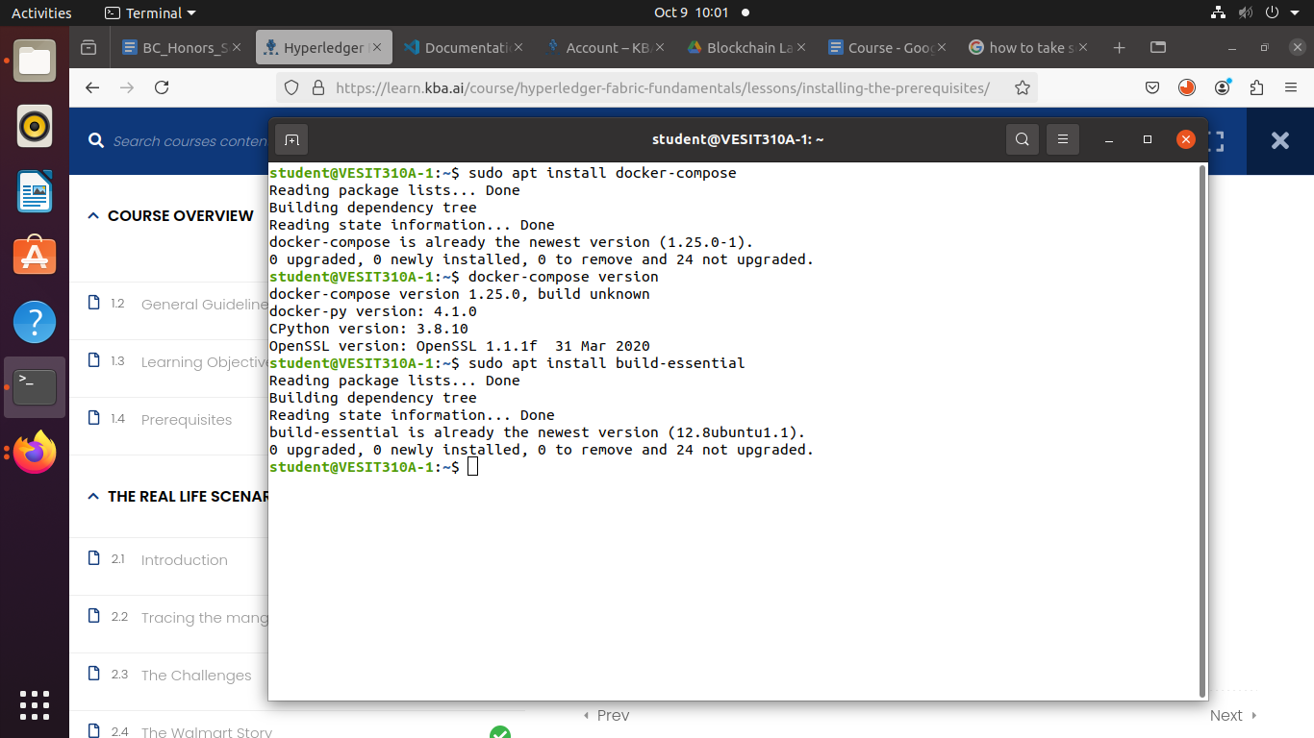

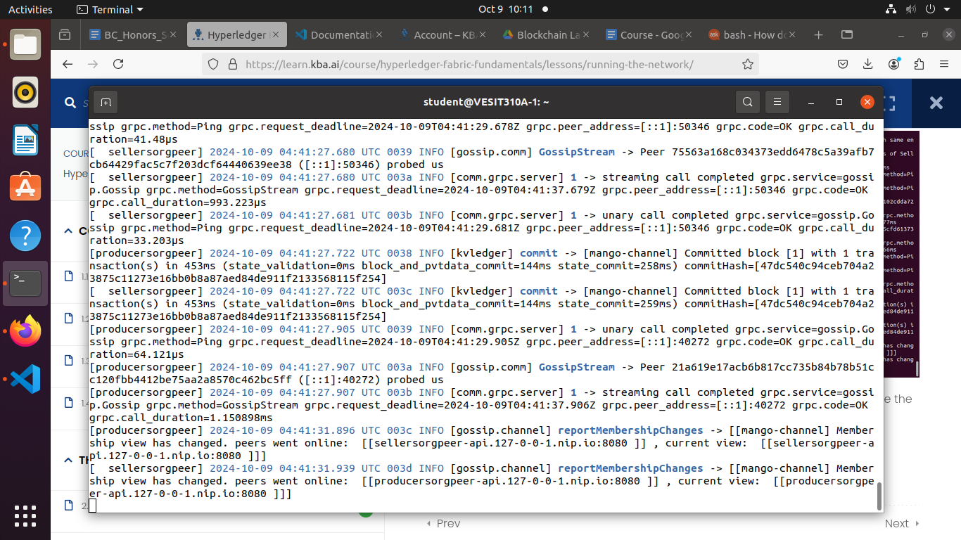

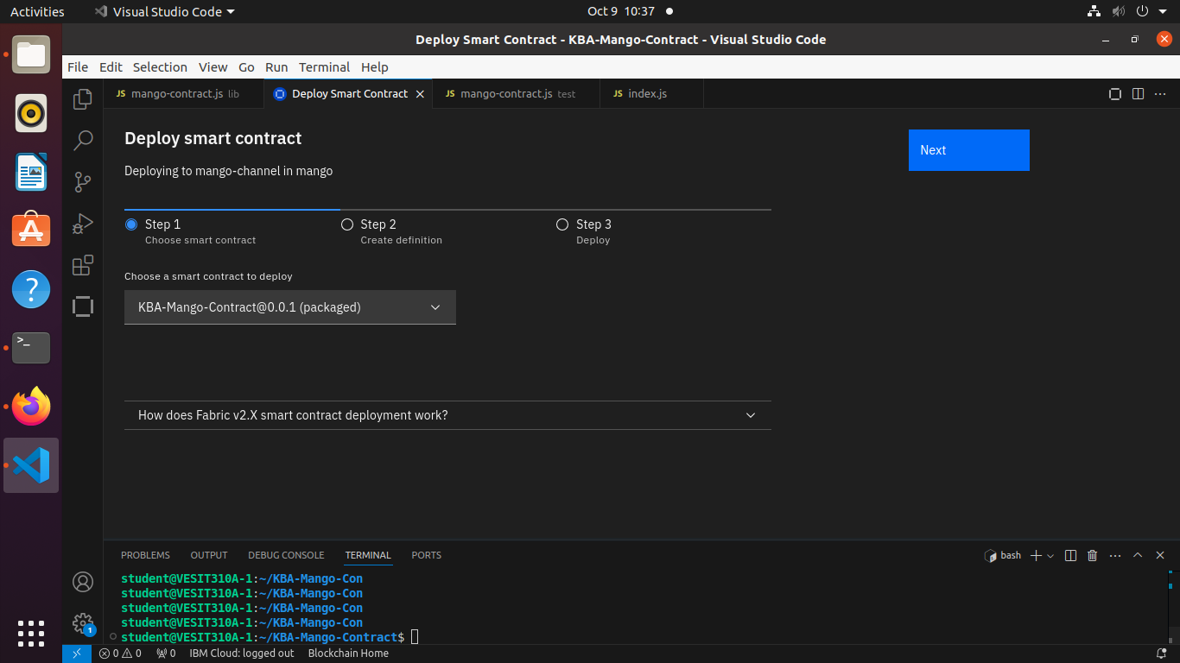

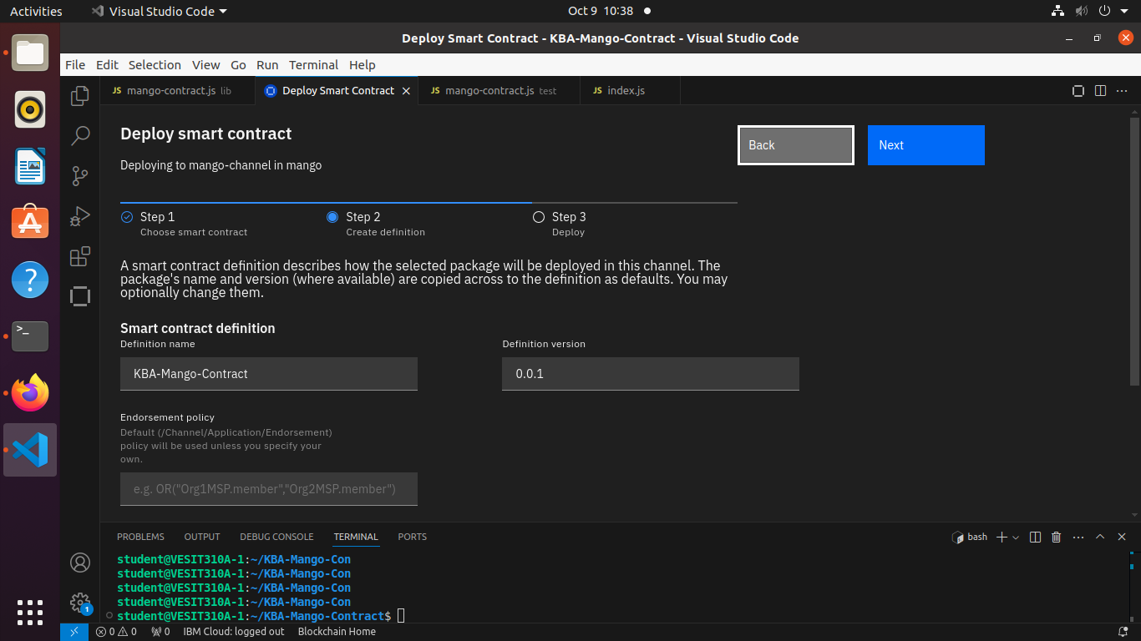

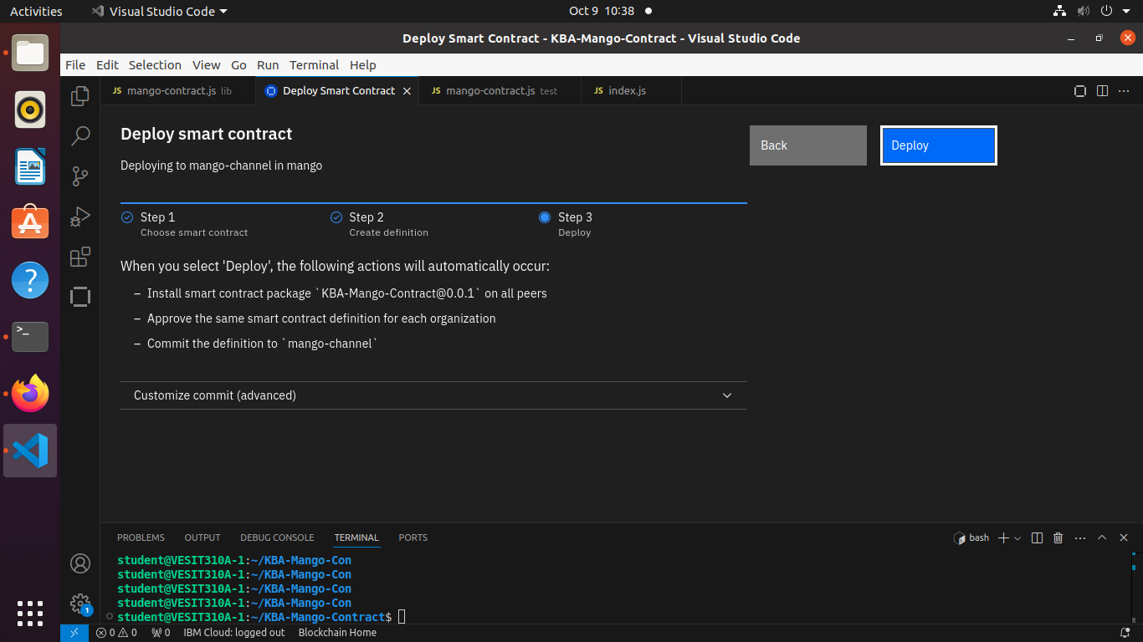

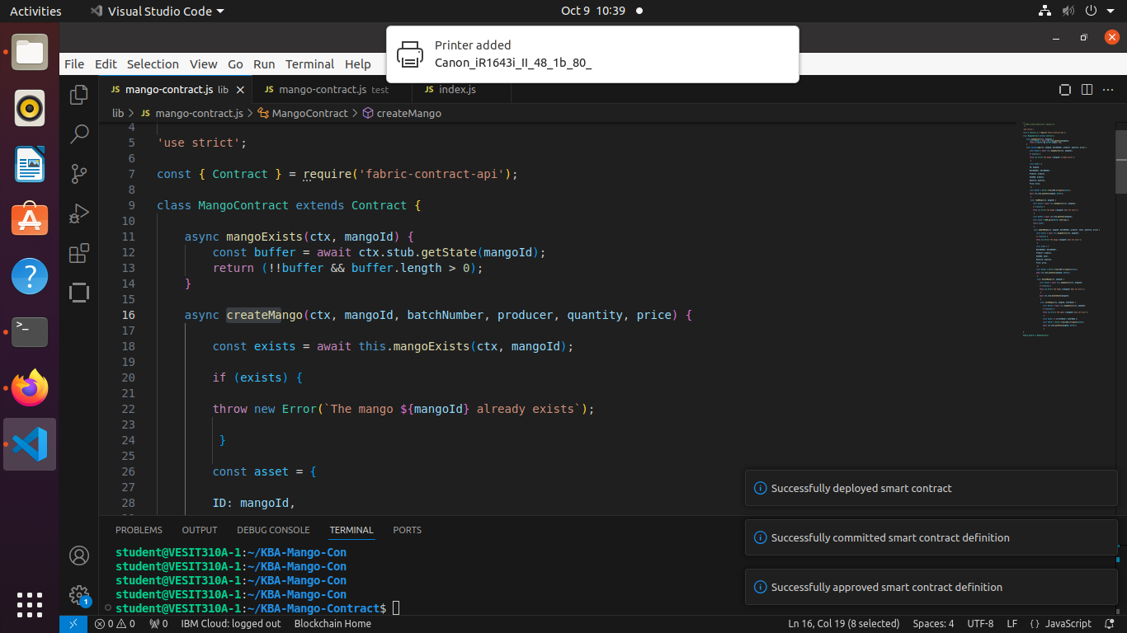

Create Smart Contract Definition

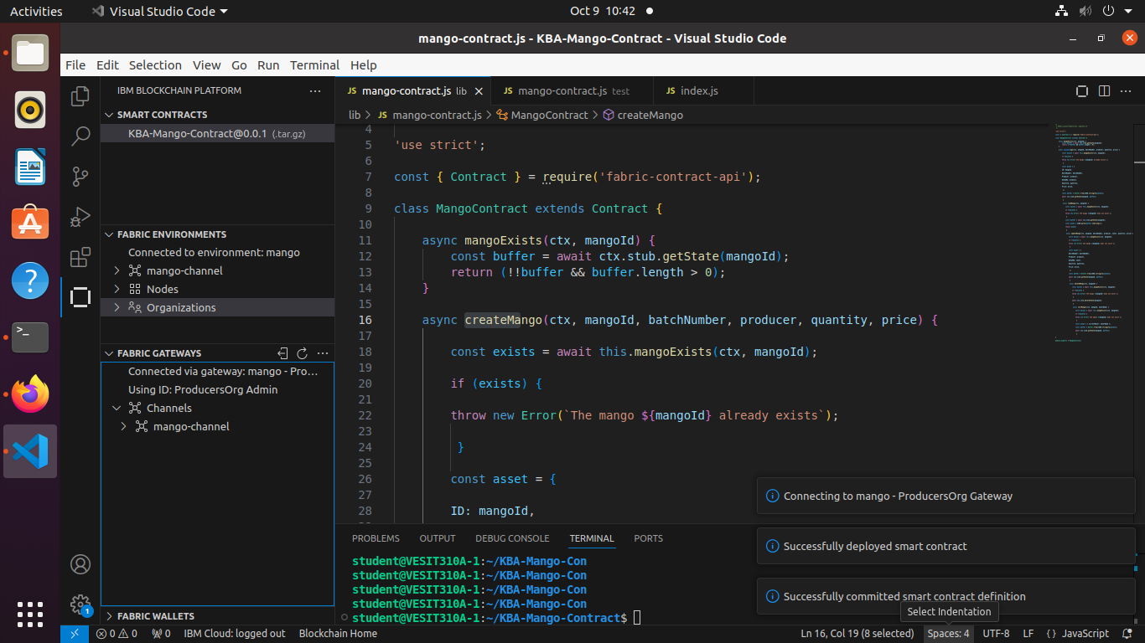

Transactions:

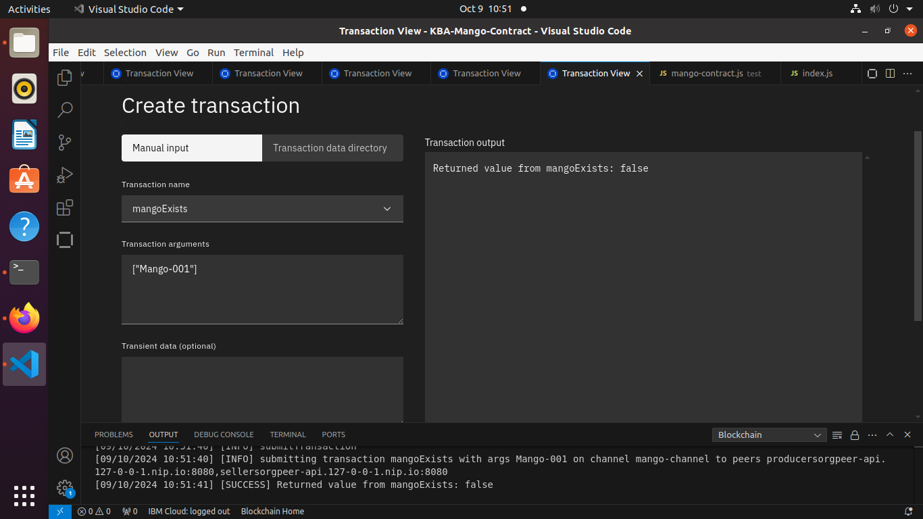

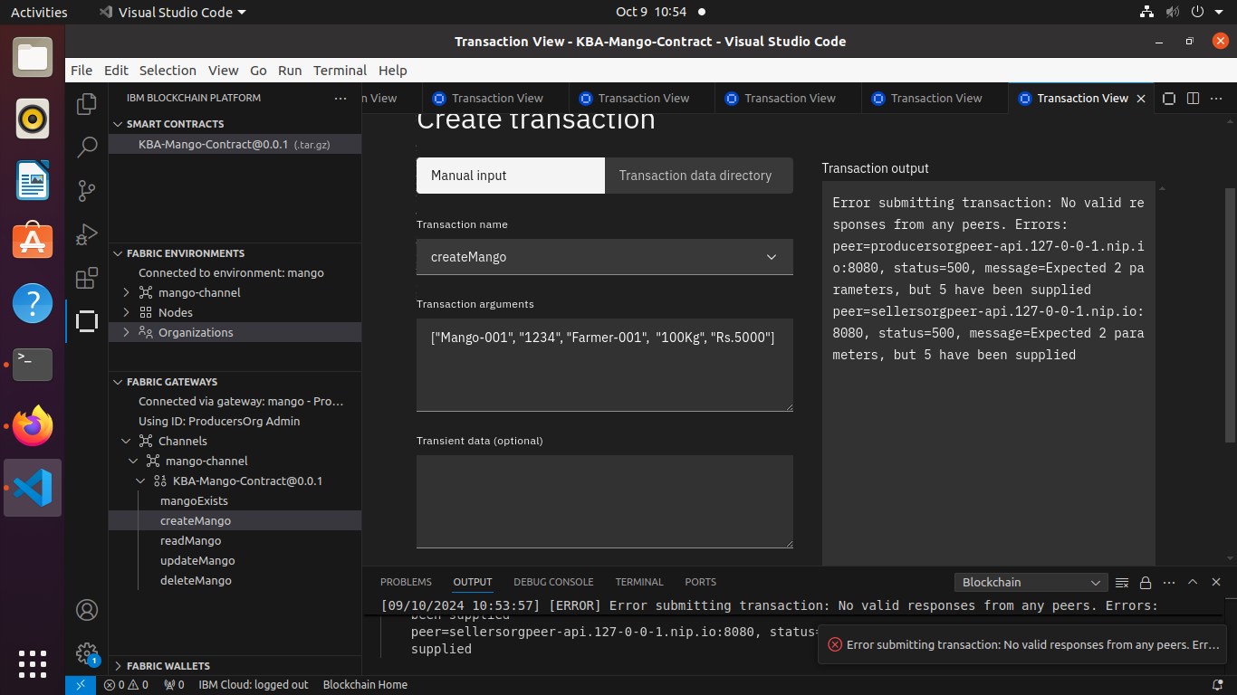

**Conclusion:** Thus , we deployed a contract using Hyperledger fabric.

